Q#1: Write a C++ program to enter length and breadth of rectangle and find its area.
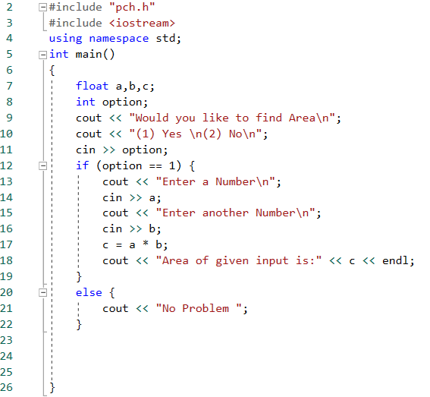

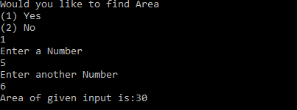

Q#2: Write a C++ program to make a mark sheet of five subject.
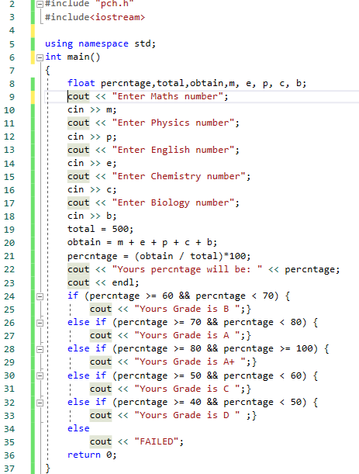

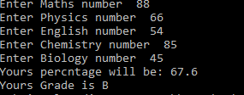

Q#3:Write a program to make calculator?
#include <iostream>
#include <stdio.h>
#include <conio.h>

using namespace std;

int main()
{
float num1;
cout << "Enter the first Number";
cin >> num1;
char oprte;
cout << "Choose a Operator(+,-,*,/)";
cin >> oprte;
float num2;
cout << "Enter the second Number";
cin >> num2;
if (oprte == '+')
{
float sum;
sum = num1 + num2;
cout << "Your answer is:" << sum;
}
else if (oprte == '-')
{
float sub;
sub = num1 - num2;
cout << "Your answer is:" << sub;
}
else if (oprte == '*')
{
float mul;
mul = num1 * num2;
cout << "Your answer is:" << mul;
}
else if (oprte == '/')
{
float divi;
divi = num1 / num2;
cout << "Your answer is:" << divi;
}
else
{
cout << "Syntax Error";
}
system("pause");
return 0;
}

Enter the first Number24
Choose a Operator(+,-,*,/)/
Enter the second Number2
Your answer is:12
Press any key to continue . . .

Q#4:Write a program to check whether a number is even or odd.

#include<iostream>

using namespace std;

int main()
{
int a;
cout << "enter the number:";
cin >> a;

if (a % 2 == 0)
cout << "\nEven number";
else
cout << "\nOdd number";
system("pause");
return 0;
}
enter the number:7

Odd number
Press any key to continue . . .

Q#5:Write a program to check whether a year is leap year or not.

#include <iostream>
#include <stdio.h>
#include <conio.h>

using namespace std;

int main()
{
int year;
cout << "Enter the Year";
cin >> year;
if (year % 4 == 0)
{
cout << year << "is a leap year";
}
else
{
cout << year << "is not a leap year";
}
system("pause");
return 0;
}
Enter the Year2018
2018is not a leap year
Press any key to continue . . .

Q#6:Write a program to input any alphabet and check whether it is vowel or consonant.

#include <iostream>
#include <stdio.h>
#include <conio.h>

using namespace std;

int main()
{
char val;
cout << "Enter an Alphabet:"<<endl;
cin >> val;
if (val == 'a' || val == 'e' || val == 'i' || val == 'o' || val == 'u' || val == 'A' || val == 'E' || val == 'I' || val == 'O' || val == 'U')
{
cout << "It is a Vowel";
}
else
{
cout << "It is a Consonant:"<<endl;
}
system("pause");
return 0;
}
Enter an Alphabet:
r
It is a Consonant:
Press any key to continue . . .

Q#7Write a program to check whether a number is divisible by 5 and 11 or not.

#include <stdio.h>
#include <conio.h>
#include <iostream>

using namespace std;
int main()
{
int num;
cout << "Enter any number:";
cin >> num;

if ((num % 5 == 0) && (num % 11 == 0))
{
cout << "Number is divisible by 5 and 11";
}
else
{
cout << "Number is not divisible by 5 and 11";
}
system("pause");
return 0;
}
Enter any number:55
Number is divisible by 5 and 11
Press any key to continue . . .

Q#8:Write a program convert decimel to binary?

#include <stdio.h>
#include <conio.h>
#include <iostream>

using namespace std;
int main()
{
int n, c, k;

cout<<"Enter an integer in decimal number system:"<<endl;
cin>>n;

cout<<" binary number system is:"<<endl;

for (c = 31; c >= 0; c--)
{
k = n >> c;

if (k & 1)
Enter an integer in decimal number system:
44
binary number system is:
0
0
0
0
0
0
0
0
0
0
0
0
0
0
0
0
0
0
0
0
0
0
0
0
0
0
1
0
1
1
0
0
endlPress any key to continue . . .
cout<<"1"<<endl;
else
cout<<"0"<<endl;
}

cout<<"endl";

system("pause");
return 0;
}

